***Hrithik Sagar***

***2018004036***

***CSE C G2***

***Bootcamp G4***

***To: Preeti Koushik ma’am***

***Date: 12th June 2021***

**Calculator program using custom heeder file:**

Header file:

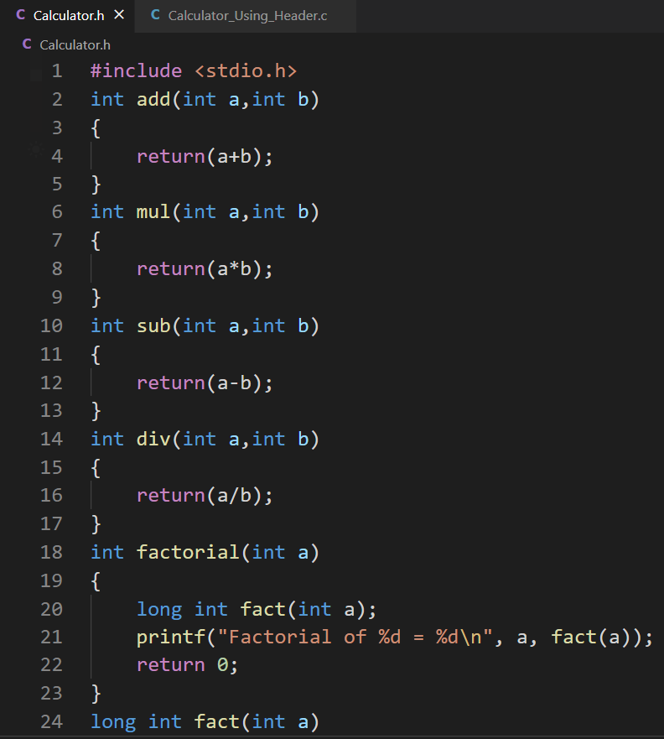

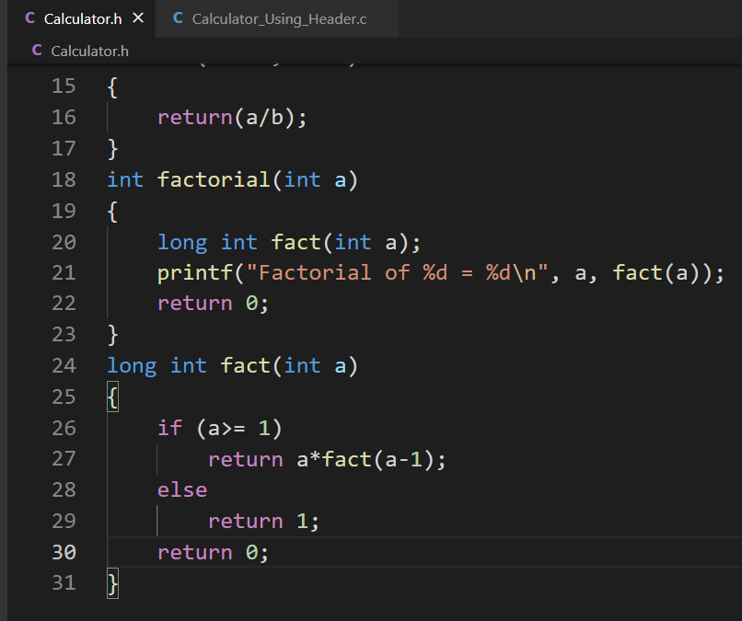

Main code:

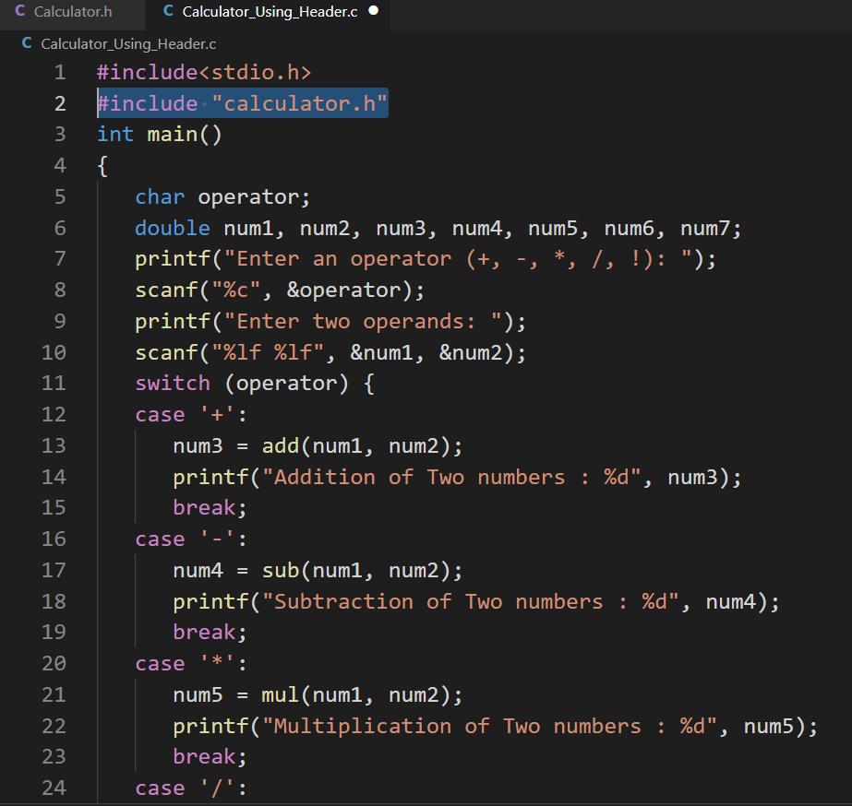

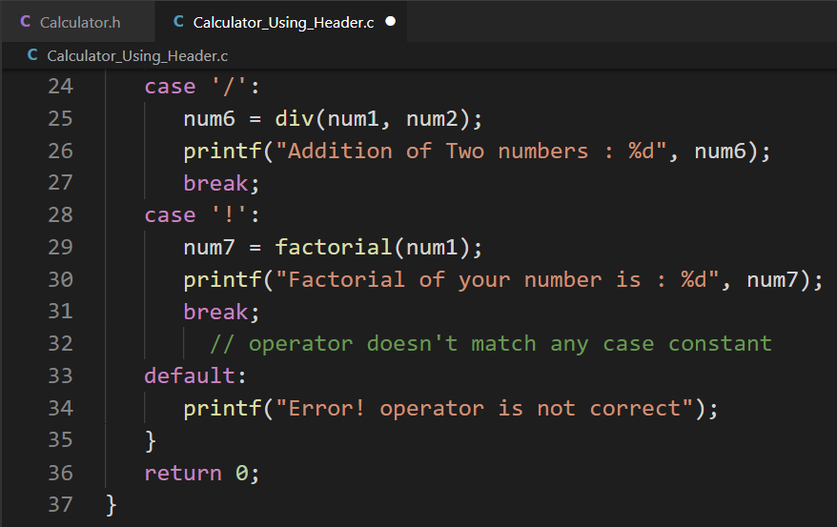

Output: 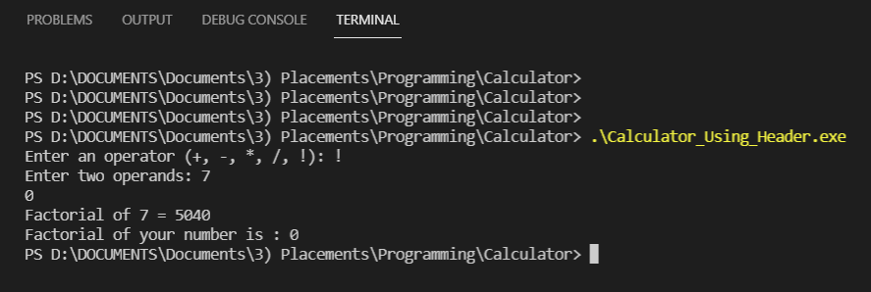

Done by Hrithik Sagar

On 12th June 2021

**TOWER OF HANOI:**

#include <stdio.h>

#include <string.h>

#include <stdbool.h>

bool palRec(char str[], int s, int e){

if (s == e)

return true

if (str[s] != str[e])

return false;

if (s < e + 1)

return palRec(str, s + 1, e - 1);

return true;

}

bool isPalindrome(char str[]){

int n = strlen(str);

if (n == 0)

return true;

return palRec(str, 0, n - 1);

}

int main()

{

char str[20];

printf("Enter the string to check whether it is Palindrome or not: ");

scanf("%s", &str)

if (isPalindrome(str))

printf("'%s' is a Palindrome.", str);

else

printf("'%s' is not a Palindrome.", str);

return 0;

}

PALINDROME

#include <stdio.h>

#include <string.h>

#include <stdbool.h>

bool palRec(char str[], int s, int e){

if (s == e)

return true;

if (str[s] != str[e])

return false;

if (s < e + 1)

return palRec(str, s + 1, e - 1);

return true;

}

bool isPalindrome(char str[]){

int n = strlen(str);

if (n == 0)

return true;

return palRec(str, 0, n - 1);

}

int main()

{

char str[20];

printf("Enter the string to check whether it is Palindrome or not: ");

scanf("%s", &str);

if (isPalindrome(str))

printf("'%s' is a Palindrome.", str);

else

printf("'%s' is not a Palindrome.", str);

return 0;

}